***Task 2***

**Problem Statement-**

1.At a new club most of the football managers find it difficult to build an all round team. The most prolific reasons are- tight budget, the club doesn’t see a stream of revenue coming in from the player in the future. This leads to the formation of a weak team which is unable to give the bigger clubs any competition. By the end of the season this team wins no trophy and loses another stream of revenue. For the next season this cycle continues and that is why very few to none clubs have grown in football and challenged the giant clubs.

2. Have you ever felt that while playing FIFA some of your players missing simple chances, making silly errors and blanking out for a second? This is not your fault. This is due to the fact that the player has a low statistic for that very situation or is not suited to your style of play and low statistic will cost you the game in real world football or gaming.

**My Approach-**

1.As a data scientist to my manager, I’m going to provide an all round complete team with a tight budget and such players who will grow under the club in the future years. This young fresh pool of players will help the club give competition to the bigger clubs and be a key member in the title race. This will help the club to grow and become a future giant.

2. Calculating a real overall for players in each position. This real overall takes into account every situation that player may experience and not only its top attributes. The real overall reduces the rating but that’s the difference in being a real manager versus in a game. This will help managers build complete squads and be prepared for every situation. It’s calculated on the basis of a particular set of attributes which is different for every position. We select players with high real overall.

**Core Idea-**

To create a team with players having a rating of 80-85, with a weekly wage of 30k-50k$ and with players in the age group of 20-30. The age gives the players time to grow and reach their max potential under the club.

Breaking it down

* The team formation is going to be that of 4-3-3(Most widely used formation in the Euros and World Cups, very effective in La liga and Serie A )
* The 4-3-3 is a high pressure, ball hungry philosophy with plenty of things going for it.
* The most effective versions of this formation employ incredibly adventurous wing-backs who bomb forward at every opportunity.
* The three central midfielders are all-action types, but rarely offer the kind of width needed for teams to find a horizontal balance, so flying left- and right-backs are a necessity.
* The formation employs one central striker and two wide forwards. They're almost always level and are required to work well with their respective full-backs.

**NOTE-**

**All comparisons are made for affordable players which reduce are scope to players less than an overall of 85.**

**Delta stands for the difference in the players potential and his current overall.**

**TOP PICKS FOR EACH POSITION**

*FORWARDS*

1. Strikers-

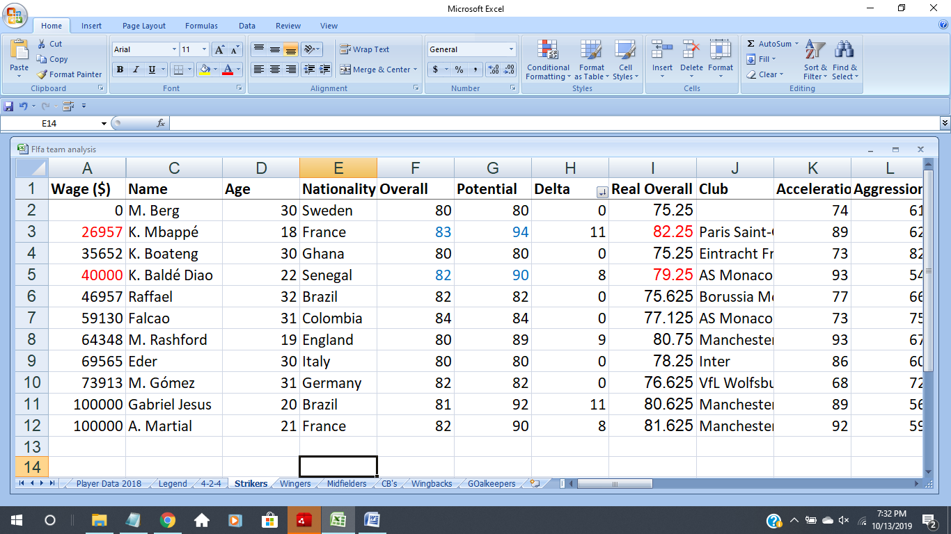Stirkers play the role of finishing the chances created by the midfielders and the wingers.. We thus create a real overall which takes into account the

* Acceleration
* Dribbling
* Finishing
* Heading
* Long shots
* Shot power
* Sprint speed
* Stamina
* Strength.

Our first pick would be Kylian Mbappe, an 18 year old with very high potential and a real overall of more than the other top picks.

On the substitute bench K Balde Diao fits in beautifully with a decent overall but high potential.

b)*Wingers*

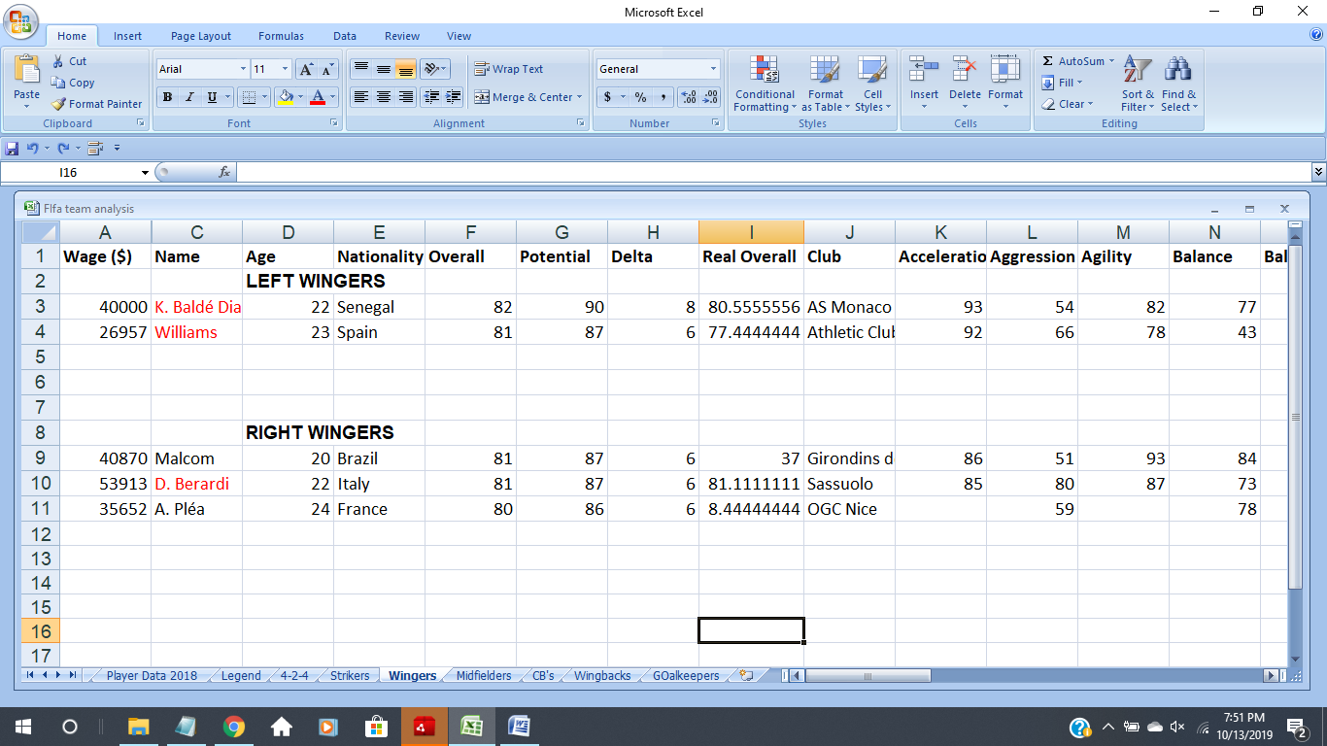In football, a winger is an attacking midfielder in a wide position. Wingers are usually players of great pace or dribbling ability so as to provide cut-backs or crosses from which strikers can score. Their main function is to support attack from the wings. Wingers do lots of high-speed running from defence to attack.

The attributes we are looking for-

* Acceleration
* Agility
* Ball Control
* Dribbling
* Crossing
* Curve
* Long passing
* Sprint speed
* Stamina

Form the data it is clear that K Balde DIao is a flexible player and can play both as a striker and winger.

Next choice for a left Winger is WIllaims

For Right Winger the first pick is D Bercadi, we don’t have sufficient data for Malcom and Plea but the pace, dribbling and more importantly crossing of these three is high which suits a winger

*MIDFIELDERS*

Midfielders play mostly in the middle of the field. For this reason, they are also known as halfbacks. Their field position is in between the defenders and forwards. In the well-oiled soccer team machine, midfielders are the gears that keep the defensive and offensive lines connected and moving smoothly. This key role often sees the most action and moves the most during a game. Midfielders play both defensive and offensive roles and must be accurate passers.

**Responsibilities**

* Transition the ball between defenders and forwards
* Keep the ball in the opponent’s area
* Stop the other team’s attacks
* Maintain possession and pass the ball
* Take free kicks and other shots on goal
* Sometimes take throw-ins

The attributes we are looking for are-

* Balance
* Ball control
* Composure
* Dribbling
* Interceptions
* Long Passing
* Short Passing
* Stamina
* Vision

In 4-3-3, 3 midfielders rule the pitch.

Top pick would be Oscar cause he isn’t playing in any club as of now.(as per data). Then is Lemar with best real overall and most importantly a really high potential.

Third would be Goretzka, being dominating midfielder always help to the squad.

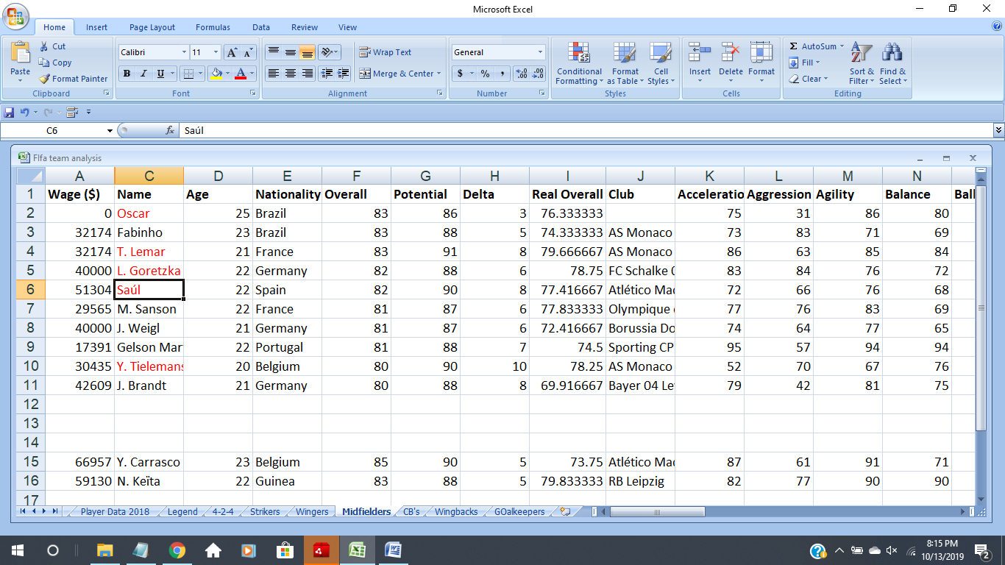

Real life example- Keita and Fabinho,both in this list were scouted by Liverpool and they have led Liverpool to the Champions League.

**DEFENDERS**The defenders are the players situated in front of the goalie. In general, a defender’s primary area of play is the defensive third of the field, closest to their own net.

**Responsibilities**

* Protect the goalie
* Block shots
* Stop the other team’s offensive players from passing, receiving, shooting and scoring
* Find opportunities to move the ball forward on the field via passing
* Take throw-ins
* Sometimes take goal kicks

The Attributes we are looking for-

* Aggression
* Composure
* Ball control
* Heading
* Interceptions
* Marking
* Positioning
* Stamina
* Standing tackle and Sliding Tackle

*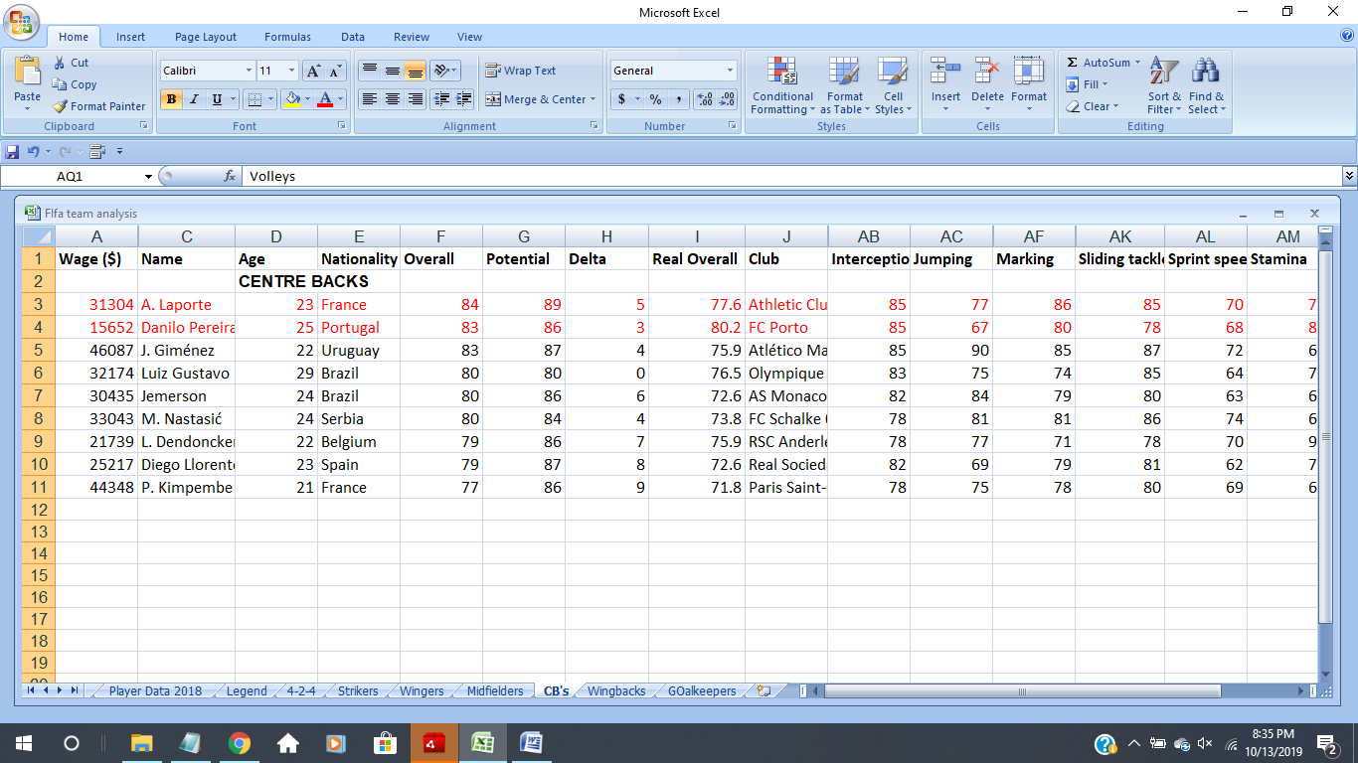Centre Backs(CB)*

The top picks are Danilo Pereira and A Laporte. Real life example- A Laporte ere scouted by Manchester City and today is an integral part of their defense.

Wingbacks

Similar to wingers but play a dual role to both attack and defensive work.

The attributes are similar to that of a central defender only crossing, dribbling and curve is included.

For left backs R Guierrerio and Ricardo Perreira.

For right back Jaunfran and Mario Gaspar.

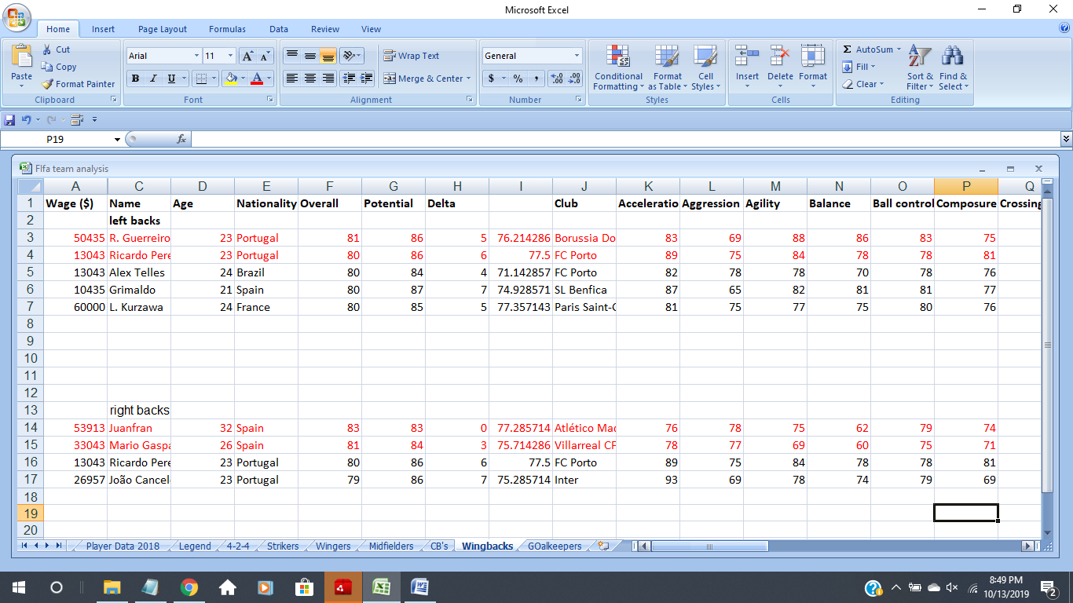

**GOALKEEPER**  
Also known as the goalie or keeper, their position is right in front of the net. Goalies are typically the last line of defense to keep the opponent from scoring. This is the only position allowed to use hands and arms to block shots and pick up the ball during gameplay, but this only applies within the designated penalty area. A goalie cannot use their hands to play the ball if a teammate passes the ball directly to them during gameplay or via a throw-in.

**Responsibilities**

* Protect the net
* Block shots with any part of the body
* Direct and organize the defense
* Find opportunities to move the ball forward on the field
* Punt and usually take goal kicks

The attributes we are looking for are-

* GK Diving
* GK Reflexes
* GK Positioning
* GK kicking
* Long passes
* Short passes
* Ball Control

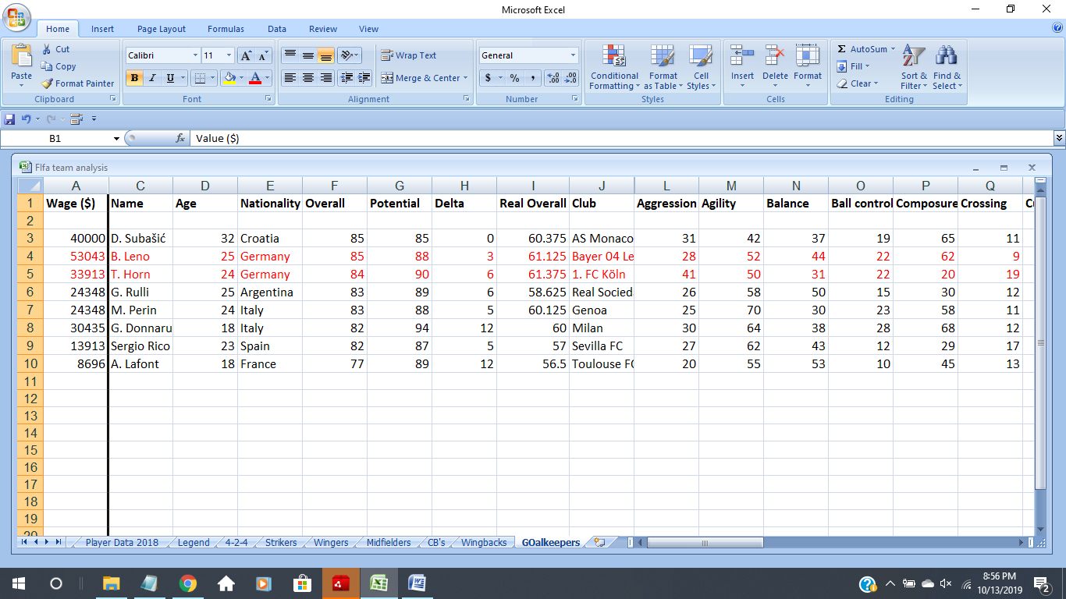The top picks are B. Leno and T. Horn.Also G. Donnaruma has extremely high potential, he could be added to the scout list.

**Conclusion**

With the help of overall Ratings and tight budget, a team was built.

Total wages for the below given squad will be $405473 which is less than the individual weekly wage of Critiano Ronaldo, Lionel Messi and Luis Suarez.

83 Rated Squad

Attack-82

Mid-83

Def-83

This is only the beginning, if we are able to get players to grow the ratings will increase and the overall squad would strengthen.

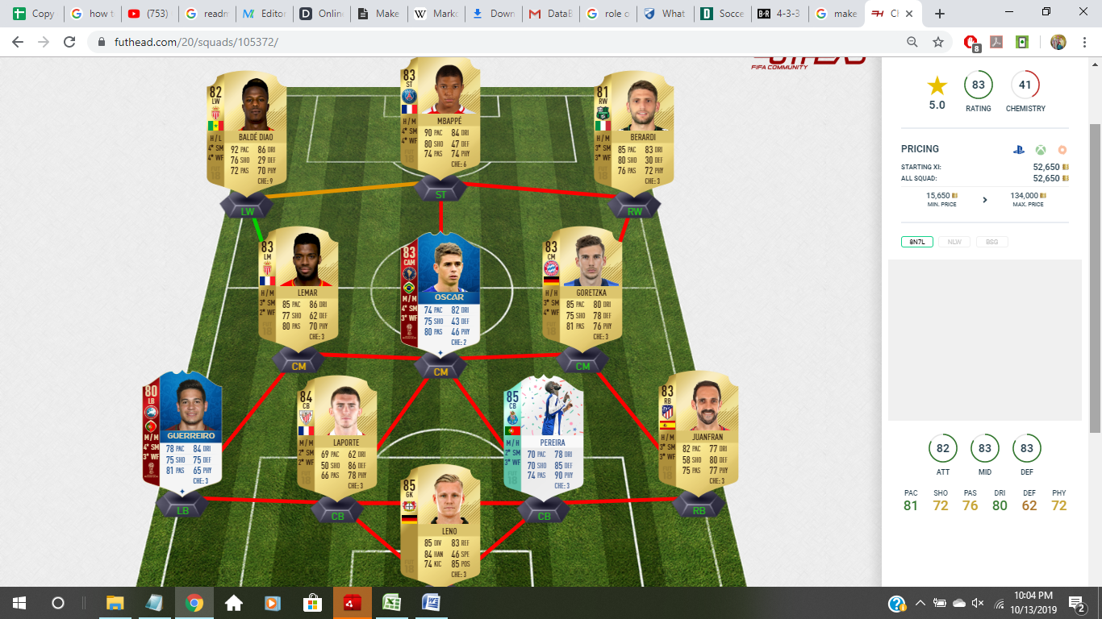

Tools used-Excel

**Acknowledgements**

I would like to thank FIFA because playinng FIFA has given me a different perspective and helped me make this project.i would laos like to thank DataByte to give me this opportunity to do this project.